# Robot Control and Systems

Learn about the tools and tricks for connecting to, controlling and monitoring your robot.

## ScreenStepsLive

<http://wpilib.screenstepslive.com/s/currentCS>

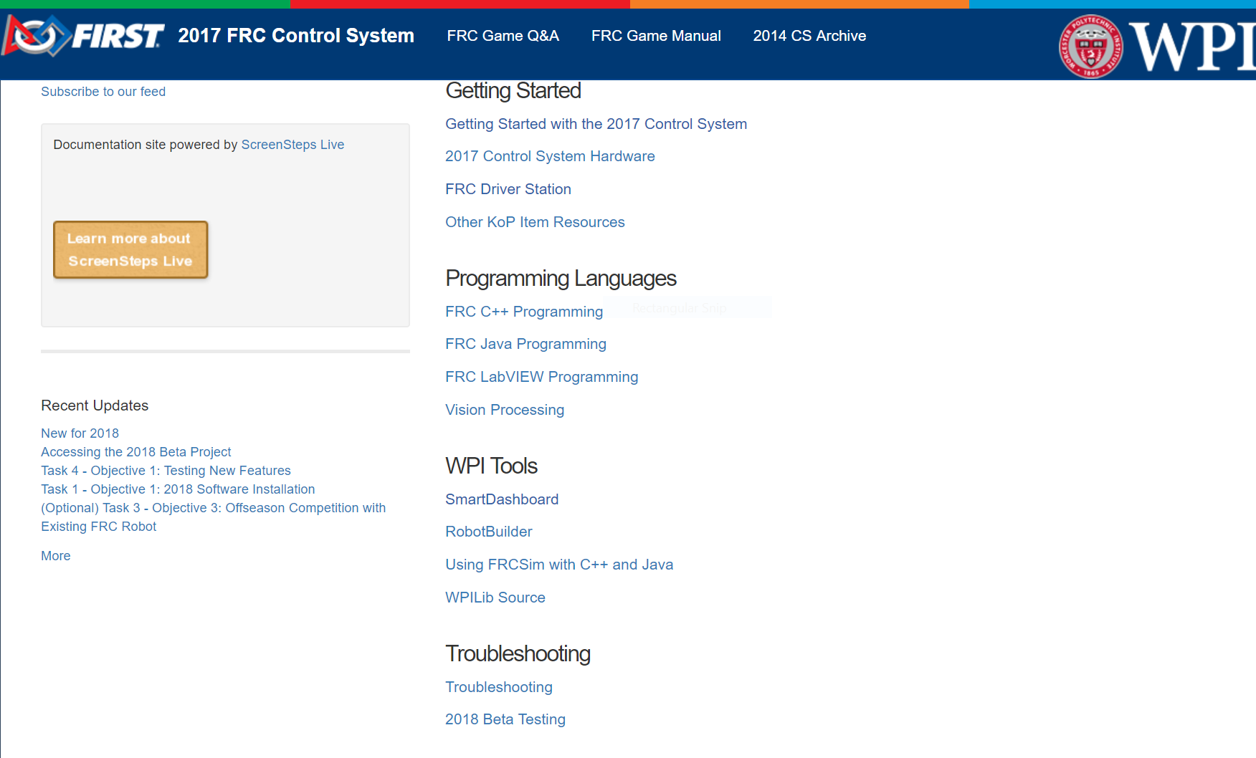

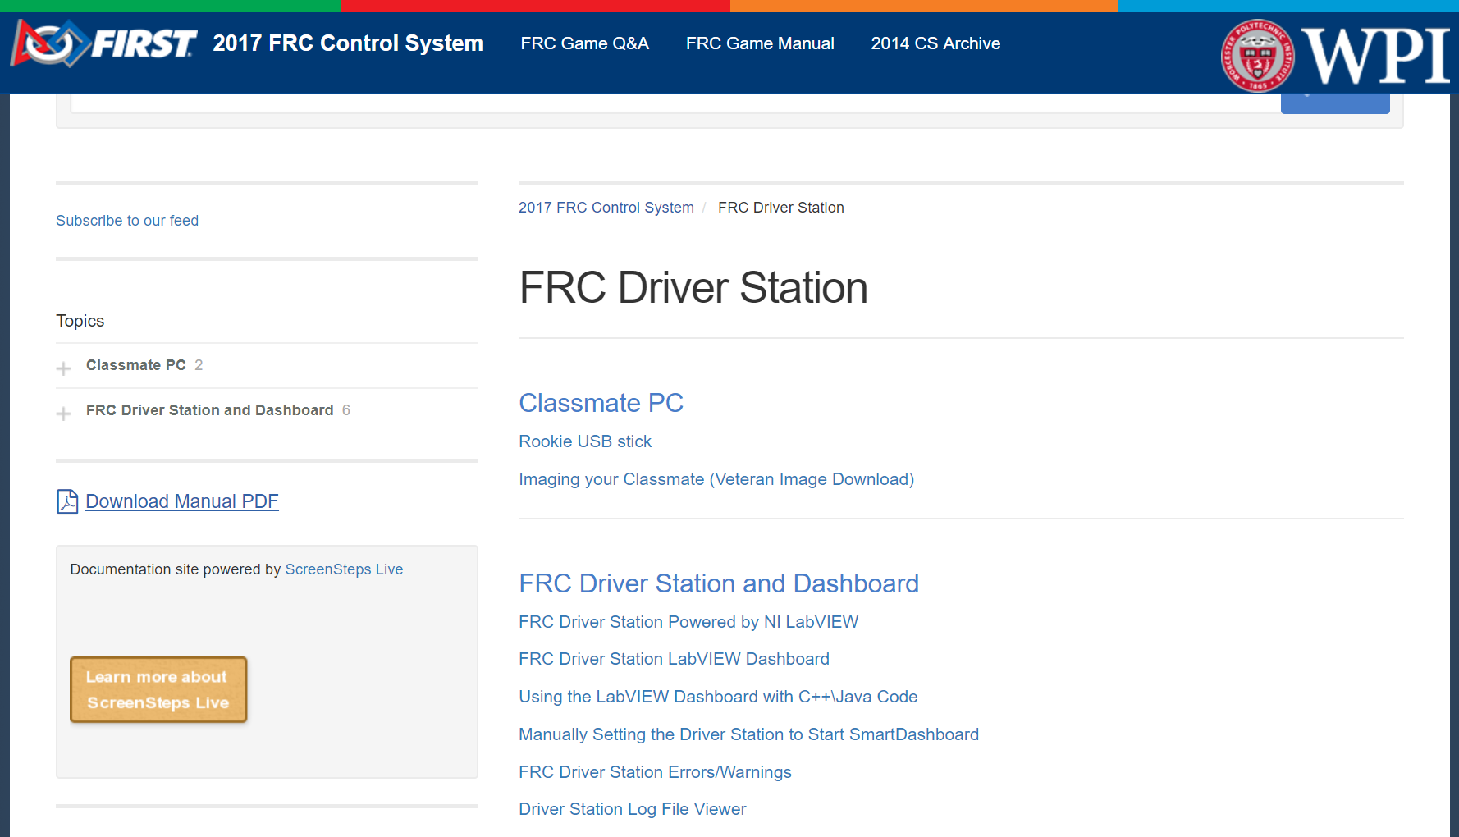

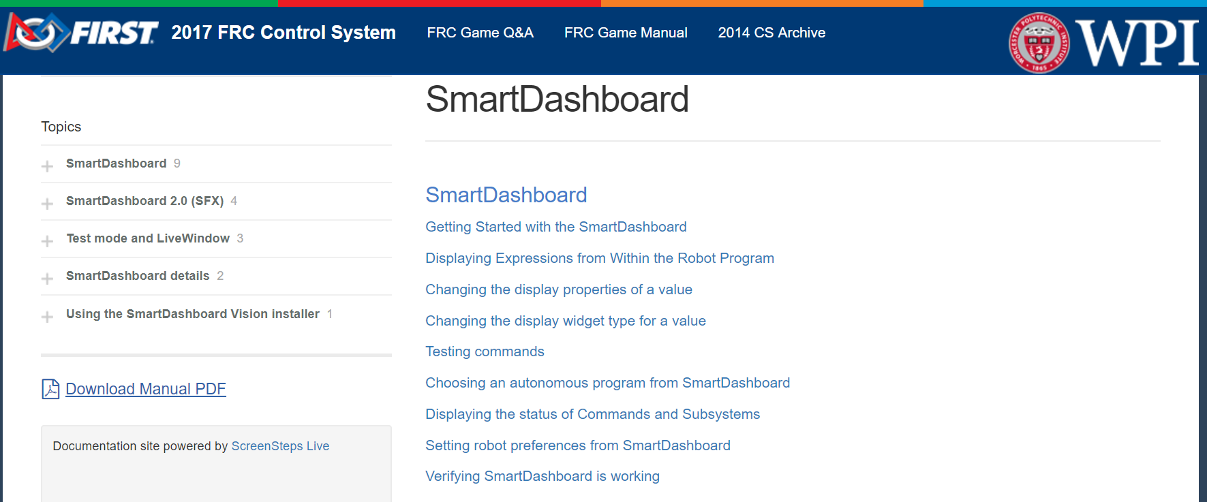

# The RoboRIO

The heart of the electronics system

Interfaces with all devices

Used to update and configure all CAN devices

Runs the code that makes the machine a robot

## Web-based system configuration

Requires Microsoft Silverlight and Internet Explorer

**Go to Control Panel 🡪 View network status -> Change adapter settings**

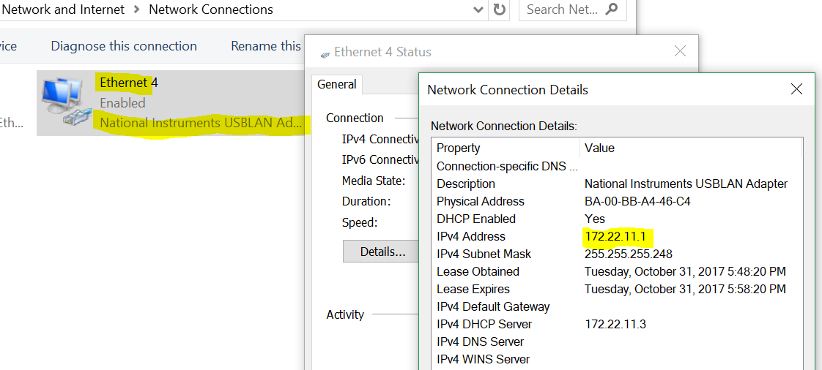

Check the properties of the Ethernet adapter for National Instruments

Note the IP address assigned to your PC the RoboRIO will end with a .2, like 172.22.11.2

## IP Connection options

4 Ways to connect to the RIO

USB cable (Local Link)

Wired Ethernet via Access Point (Dynamic IP mDNS roboRIO-4564-FRC)

Wireless via Access Point (Dynamic IP mDNS roboRIO-4564-FRC)

Wired Ethernet direct to roboRIO (static address on RIO and PC)

USB is most direct approach

great for troubleshooting

necessary for roboRIO imaging

Launch Internet Explorer and connect via IP address 172.22.11.2

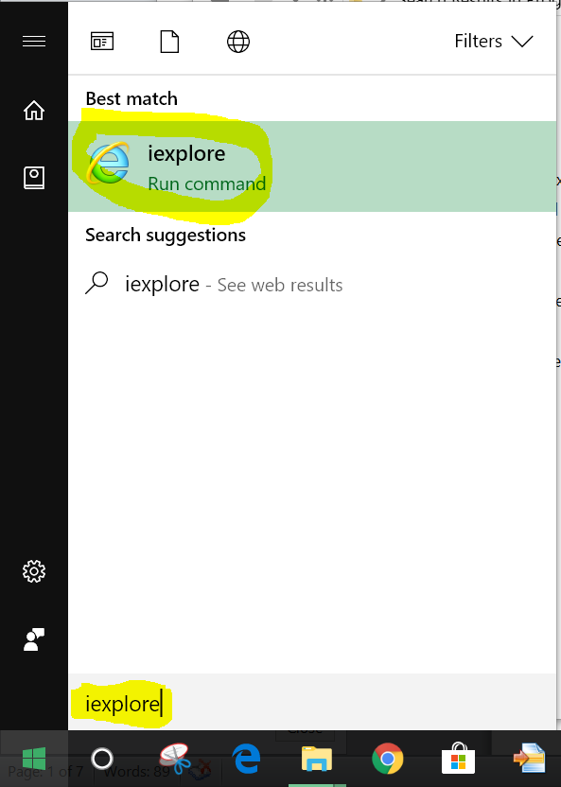

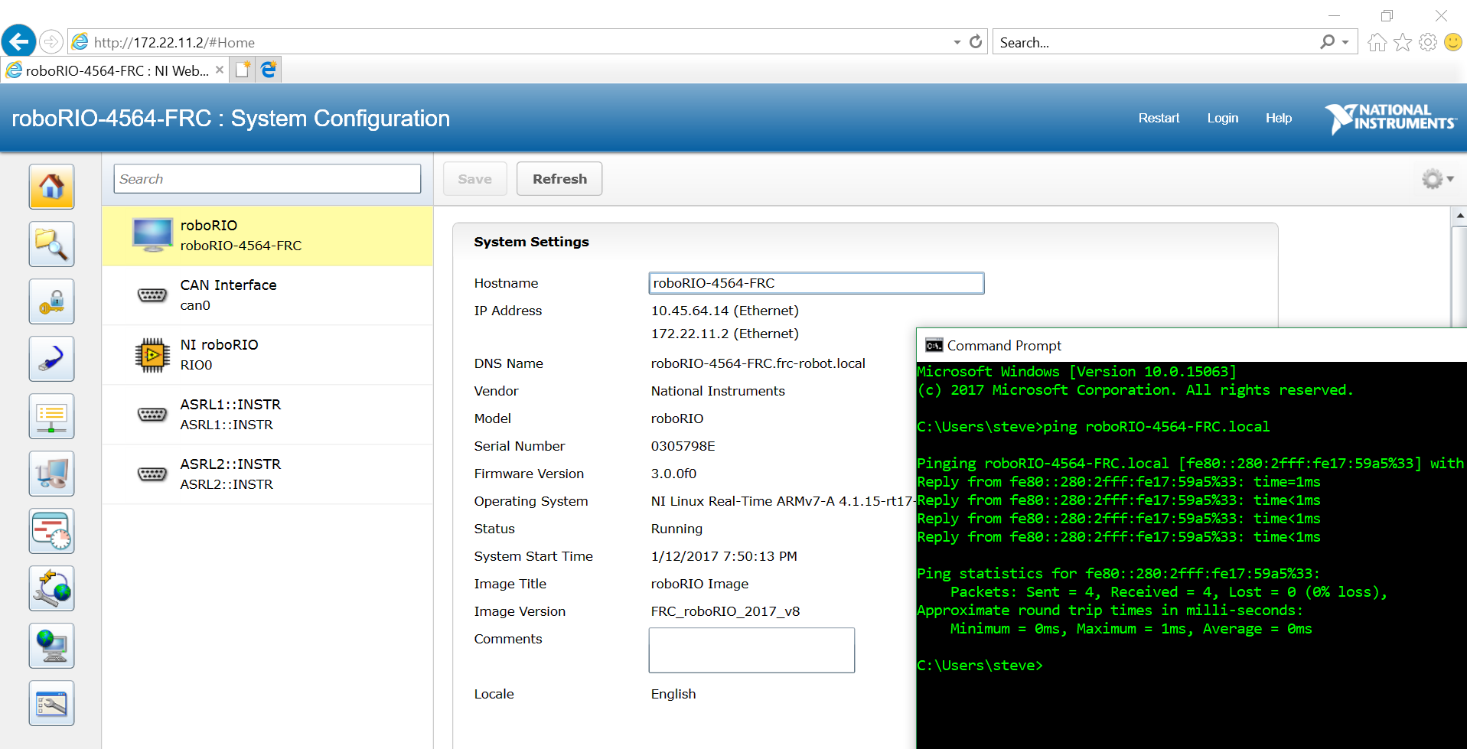

Show the multiple ways to connect:

172.22.11.2, via USB

10.45.64.14 via Ethernet (DHCP from Access Point)

roboRIO-4564-FRC.local via Ethernet

Consider setting static IP address on roboRio

Access point is always 10.xx.yy.1

Make roboRio 10.xx.yy.2

## Devices and Firmware

CAN devices will appear

Verify firmware and update them from here

Firmware updates: roboRIO, PDP, PCM, Talons

Configure CAN ID for CAN based motor controllers

Identify devices – Flash lights

## Driver Station

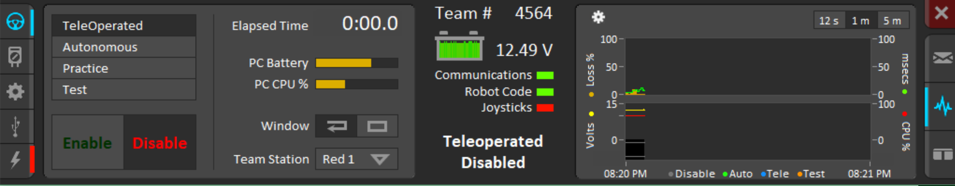

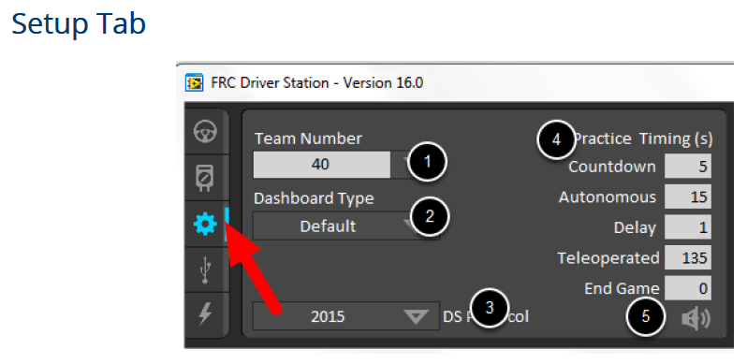

Shift-click team number to see RoboRIO mDNS names

Practice Mode settings – simulates match timings, auto/teleop modes, and sounds.

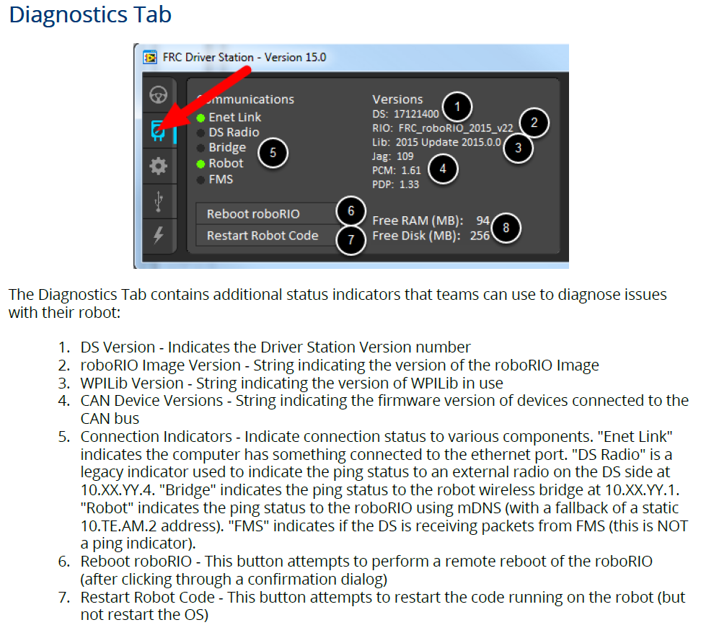

FRC Inspection Checklist

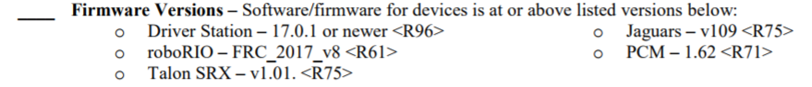

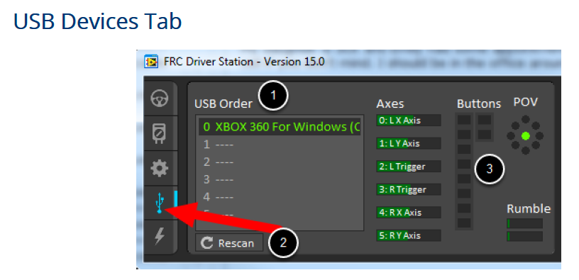

Joystick status and testing

Swapping joysticks

Locking joystick to slot – double click

## Message Console

RIO boot process

Program errors

Output from code for debug

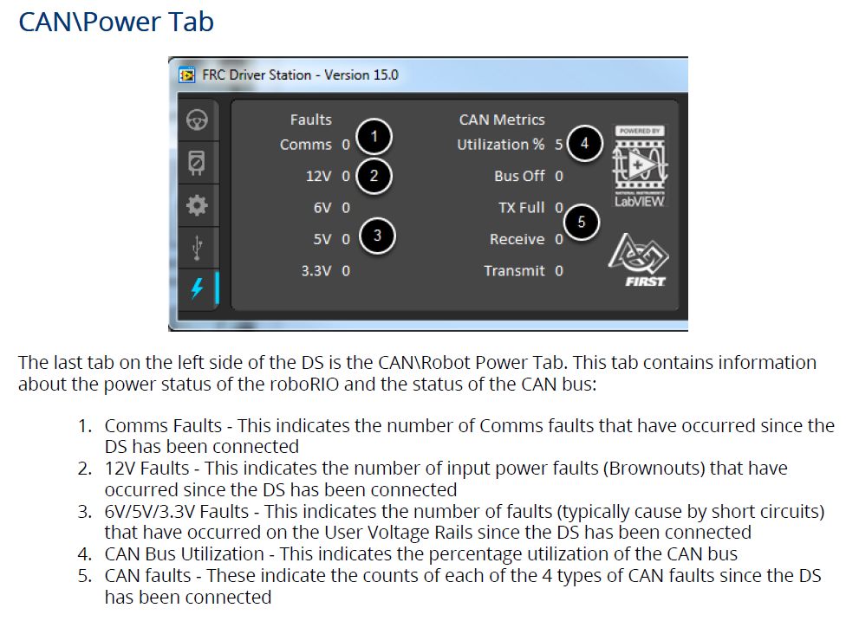

## SmartDashboard

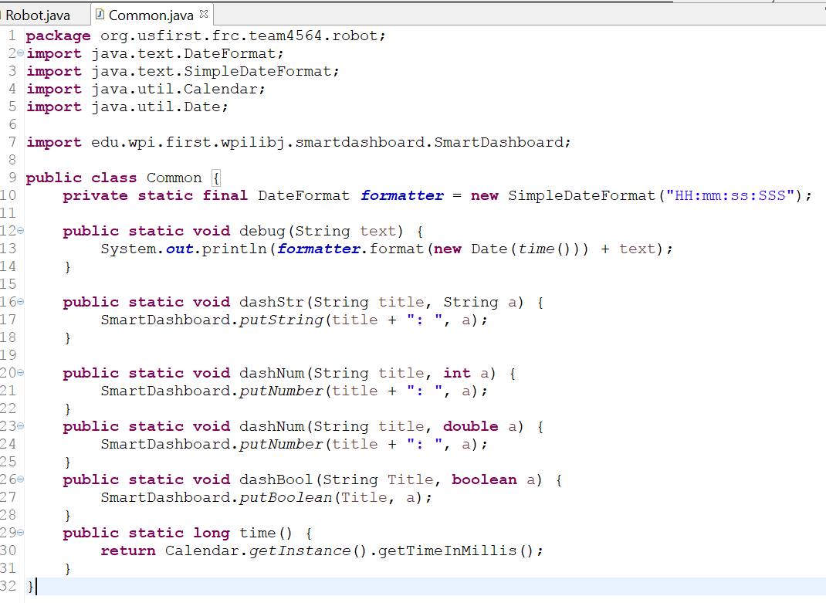

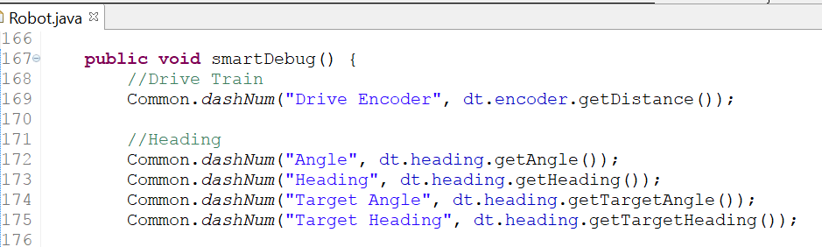

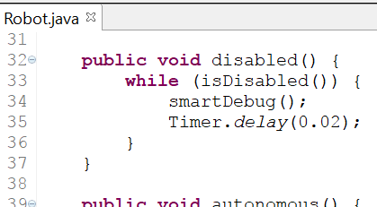

### WiFi radio-FRC Bridge utility

Configure for home use

Disable Wi-Fi (airplane mode)

Ethernet – PC to (which port?)

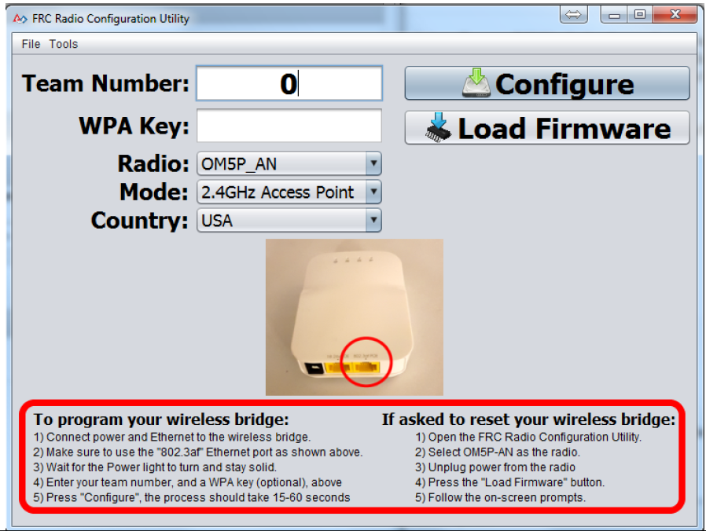

Status Lights – Troubleshooting

